CENTRAL ARCHIVE - HELP MANUAL
1

- PROCESS FOR SENDING DOCUMENTATION TO THE ARCHIVE

- REQUEST FOR MATERIAL: BOX, LABEL, and PACKING BOX (obligatory use: FCC BOX AND LABEL).
- CLASSIFICATION OF DOCUMENTATION (INSERT IN BOXES).
- COMPUTERISING OF DOCUMENTATION IN SAP – Place labels on boxes.
- SENDING PROCESS: Insert in packing boxes, fill in entry request template, request messenger service.

- DOCUMENTATION CONSULTATION

- PROCESS FOR SENDING DOCUMENTATION TO THE ARCHIVE

- REQUEST FOR MATERIAL

The following material is needed (OBLIGATORY USE)

Box (*) | Ref. | 4772889 | Pack of 10 boxes.
Label | Ref. | 4847855 | Each pack serves for 15 boxes.
Packing box | Ref. | 6680316 | Capacity for four FCC boxes.

(*) – If the documentation does not fit in the standardised box, consult the Archive.
(*) – Its use is not obligatory but it must have the same properties (maximum capacity four FCC boxes).

- COMPUTERISING OF DOCUMENTATION IN PROGRAM – SAP

OBLIGATORY: One box per lot. Two boxes with the same lot number is not allowed.

CREATE LOT – LOT MODEL
Use the Archive Management program.
Click on Archive Users.
Lots creation: two transactions are required:
- Create lot.
- Archive request.
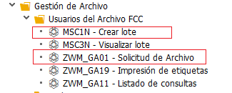

CREATE LOT
2
On entering the transaction, fill in:
Material = BOX
Then click on the classification tab.
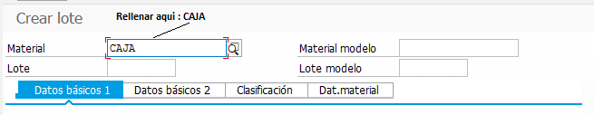
Fill in all the lot properties.
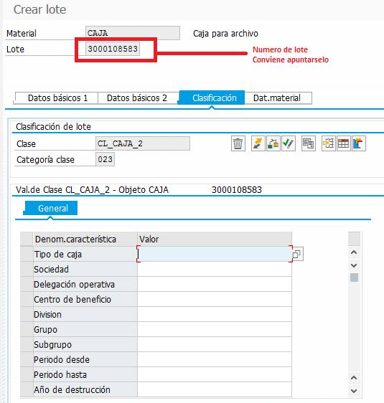
Use the boxes to specify the following:
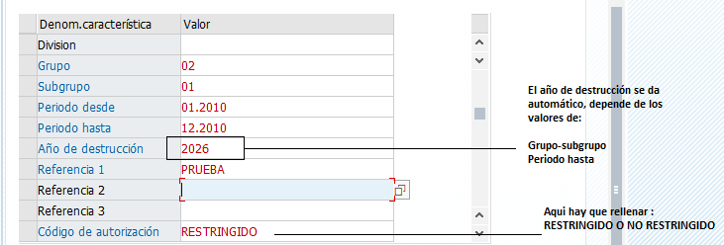

Enter “RESTRICTED” in the authorisation code box in the following cases:
- This is specified in the documentation entry request template.
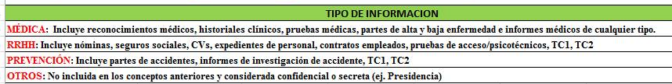
When all the boxes are filled in, click on the Save icon.
3
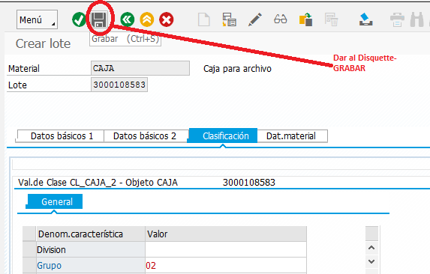
To return to enter more lots without having to fill in all the boxes again, use the LOT MODEL as follows.
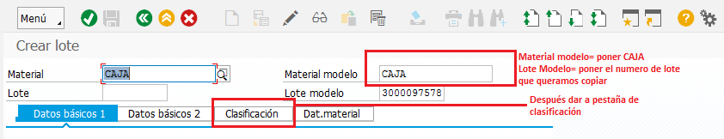
A new lot number appears. Fill in the boxes to be modified and when all is correct, click on the diskette icon.
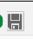

Click on the Classification tab again for a new lot number.

When all the lots data have been entered, carry out the Archive request.

ARCHIVE REQUEST

Retrieve the lots entered in the Queries list.
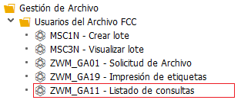
Click on the transaction and give the lots interval. Enter only this datum – do not fill in any other box since this will slow down the search. Selecting by lot number is quickest.
4

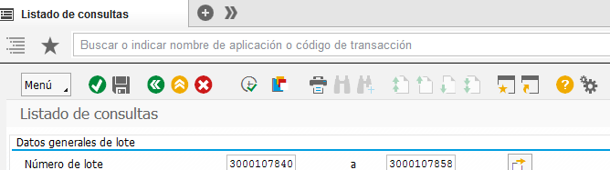
Enter the data and click on .
The program will list the computerised records.
Maintaining this mode, open another mode with the Archive request transaction.

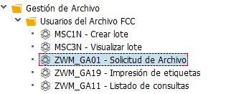

Enter Store, the relevant archive, Madrid or Barcelona, and press Enter. If Barcelona or Madrid do not appear on the drop down menu, enter:

M01 = Madrid
B01 = Barcelona
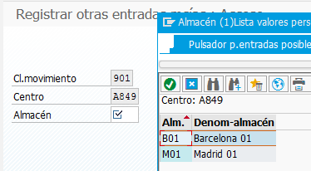

Then enter these data:
5
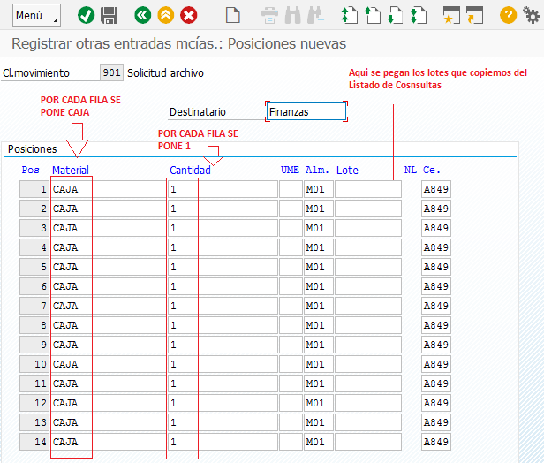

To COPY LOTS FROM CONSULTED LISTS
- CONTROL + Y = the mouse will allow the required lots to be marked.
- Drag to mark them.
- CONTROL + C = to copy the lots.
- CONTROL + V = to paste the lots.
Once the entire record is filled, validate it with .
The lots will appear one by one, using the movement icons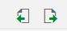.
After seeing the entire record, return to the initial page where it will appear shaded in blue to show that the process has been completed successfully.

PRINTING LABELS

Once the computerising process is complete, print the labels.
Labels can be printed from the first step in Create lot; it is not necessary to carry out the Archive request.
Click on the labels printing transaction.
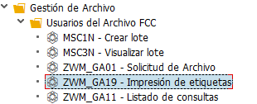
6

The quickest way to obtain the labels is to enter the lots interval.
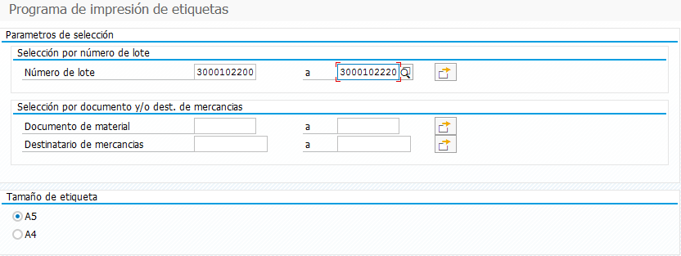

Important

The labels must be placed centred and firmly stuck to the box. Never cover the hole in the box.

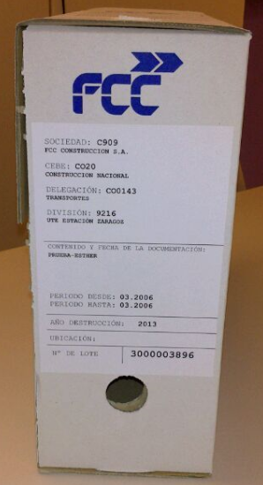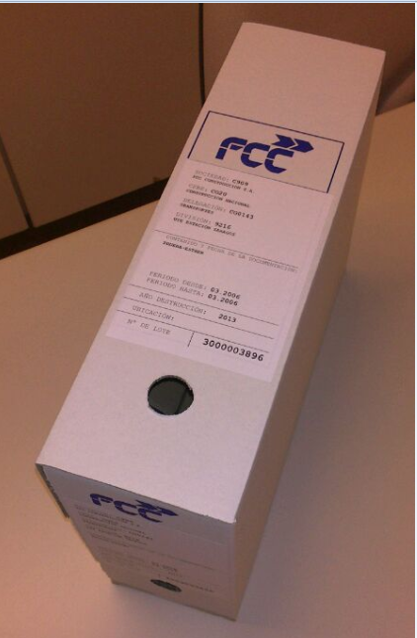
DOCUMENTATION SENDING PROCESS (packing boxes + entry request template)

Once the archive management process is complete (boxes + labels), pack the white FCC boxes in packing boxes. The packing box must have a maximum capacity of four boxes to avoid exceeding the maximum authorised weight (20 kg per box).
The manual provides a reference for the packing box used normally, although it is not obligatory.
How to insert the boxes. Insert the white FCC boxes by lot number from lowest to highest then place an identification on the top of the box giving the box number and origin:

E.g., Aqualia Zone I – Administration Department
7
Box 1/14 (if there is a total of 14 packing boxes).

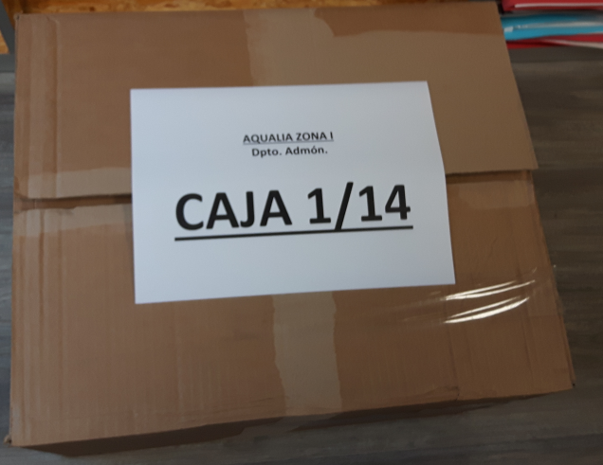

Then contact the Central Archive at archive.madrid@fcc.es and send the filled-in
- Documentation entry in Central Archive request template
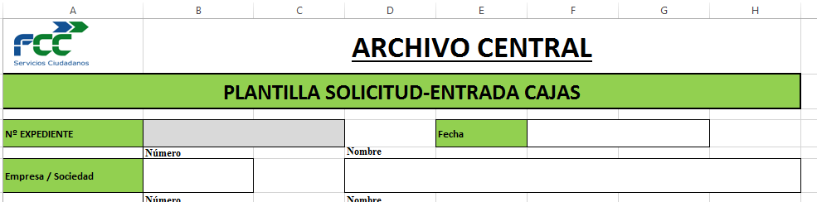

IMPORTANT
BEFORE STARTING THE BOXES + LABELS PROCESS, CONTACT THE CENTRAL ARCHIVE.

-TELEPHONE NUMBERS: 91 343 72 65, 91 343 72 56, 91 343 79 69
-E-MAIL: archive.madrid@fcc.es

- DOCUMENTATION QUERYING

Use the following steps in the program to request documentation from the Central.
Click on the Queries list transaction.
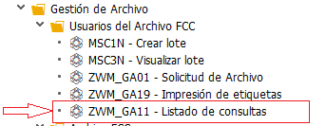
Enter the lot number to query.
9
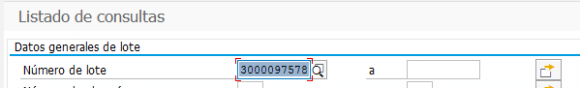
Mark the lot line in the left corner.
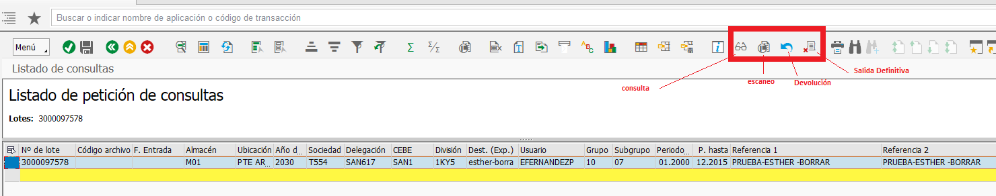
Click on the icon for the required query:
- Query.
- Scanning.
- Return.
- Definitive exit.

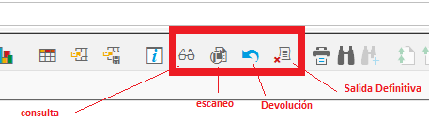

Case
If a complete box is required, click on the Request icon and leave the text field blank.
If documents are required, the text field must be filled in.
The following screen shots show examples.

Complete box query
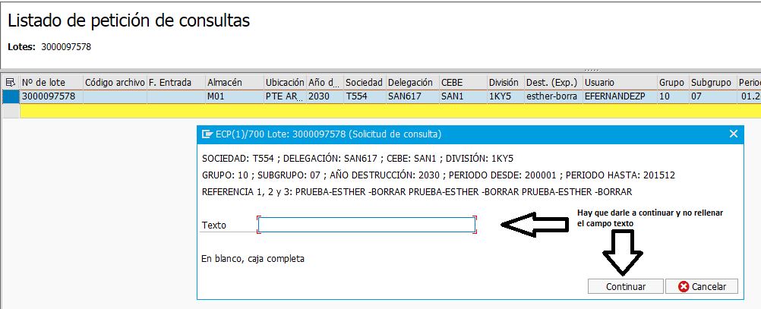
Document query
10
